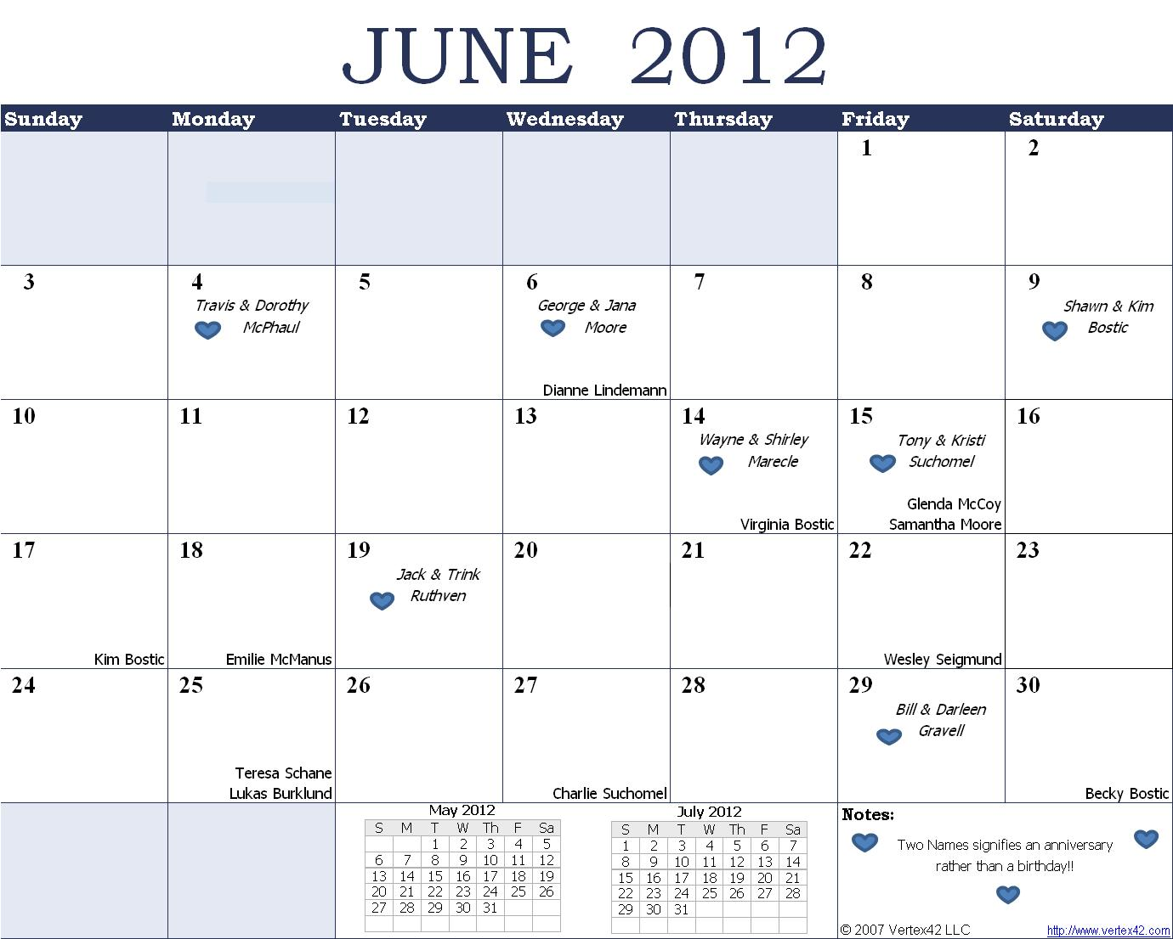

Happy Mother’s Day
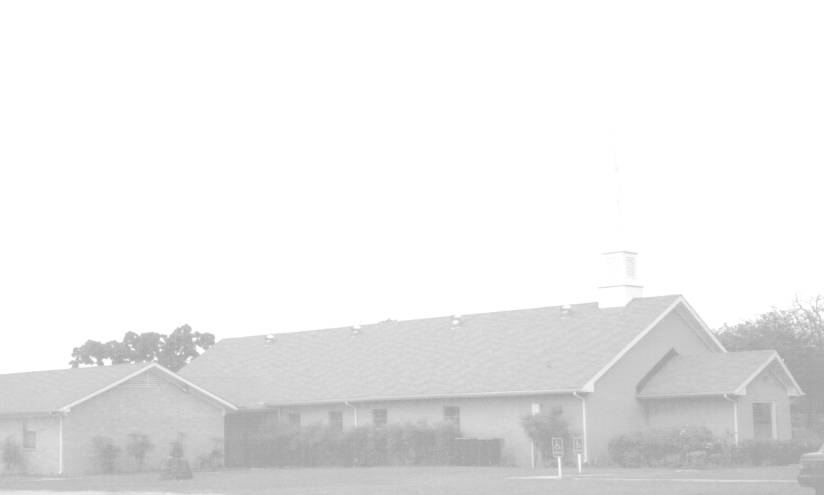
June Newsletter
Happy Father’s Day!!
Knobbs Springs Baptist Church
1662 CR 305
McDade, TX 78650
Please email KnobbsSpringsBaptist@gmail.com to be removed from our mailing list. Thanks!


Non-Profit Organization
U. S. Postage Paid
Permit # 1
McDade, Texas

BAPTIST CHURCH

1662 CR 305

McDade, TX 78650

Phone: (512) 273-2743

Email: KnobbsSpringsBaptist@gmail.com

Pastor
Bro Mark McBride
(512) 229-6555
Txloves2fish@yahoo.com

Other Contacts
Cleyon Davis – Treasurer
(512) 856-2524

Kimberly Tabor – Office Manager
(512) 698-2804

June Ushers
Geary McManus, Joe Wilson
Wesley McManus, Bill Gravell

June Hostesses
Sheila Waggoner
Judie Coffey, Theresa Bartlett

June Nursery Schedule

3 0-2 Year Olds Becky Yount
3-4 Year Olds Angie Fisher
Helper

10 0-2 Year Olds Kristi Suchomel
3-4 Year Olds Paula Knobloch
Helper

17 0-2 Year Olds Otisann McManus
3-4 Year Olds Karen Cotton
Helper

24 0-2 Year Olds Ashley Smothermon
3-4 Year Olds Jana Moore
Helper

Weekly Service & Activity Schedule:

SUNDAY
Sunday School 9:45 a.m.
Morning Worship Services 11:00 a.m.
Youth Activities 5:30 p.m.
Evening Services 7:00 p.m.

MONDAY
“Work-It-On-Out” 6:30 p.m.

WEDNESDAY
“Work-It-On-Out” 6:00 p.m.
Youth Worship 6:30 p.m.
Wednesday Services 7:00 p.m.

THURSDAY
“Work-It-On-Out” 6:30 p.m.

